Documentation of Non-CO2 Greenhouse Gas Modeling in ObjECTS GCAM
Page Kyle
January 6, 2009
Updated March 4, 2010
Updated to new ag November 7, 2010

This document identifies all data sources used and all calculations performed in mapping emissions from inventories to corresponding technologies in GCAM.

Broad Overview
The energy system and AgLU system input files are made separately, and are addressed separately in this document. In general, emissions estimates by gas, GCAM region, and source are built up from gridded estimates for the year 2000. Twelve sources are identified in the inventories; much of the data work related to non-CO2’s is dedicated to disaggregating these broad sources into the GCAM energy system and agricultural and land use technologies.

Emissions are assigned from the grid-level to country-level based on GIS tools not found in the committed nonCO2 files; the process described here starts with a series of .csv files that are output from the GIS databases. These csv files are compiled in the following file:

Input Data\Org Consensus 2000 files\EM_all_2000.xls

This workbook assigns countries to GCAM regions, and compiles the emissions by GCAM region and source. This replaces the workbooks (one for each gas) that had been provided by collaborators as part of the RCP process; the regions in these workbooks didn’t map perfectly onto the GCAM regions. For this reason we had gone through a circuitous and mistake-prone method of calibrating our emissions coefficients based on aggregating countries into IMAGE regions; part of this process involved building a separate calibration input set for IMAGE regions. This is no longer done; now all processing takes place for GCAM regions.

Note that we do not have a gridded inventory for N2O, so the same old workbook is used for N2O emissions, but it has been adjusted so that the regions map to GCAM regions to the best extent possible. The same is done for biomass burning. It will be difficult to disaggregate these emissions when we move to 24 regions, so something else will have to be done at that time.

Energy System
Input Data\Aggregated Energy GHG Data.xls
Energy Input Module\NonCO2_Energy_Input.xls

Non-CO2 gases in the energy system are calculated according to the following method:
- Emissions by each technology in GCAM are compiled from a variety of studies and data sources, such as the EPA, EDGAR 2000, the RETRO database, Lex Bouwman’s NH3 dataset, and EMF-21. In some cases exogenous emissions coefficients are used to inform the disaggregation within a sector/source.
- Emissions for the 12 sources are compiled from the RCP data as described in the previous section. Estimates of emissions by each technology in step (1) are scaled such that regional totals by source are equal to the RCP’s estimates.
- Energy consumption by all GCAM technologies is compiled for the year 2000, by exporting 2000 data from the IEA Energy Balances and feeding this through the calibration input data processing steps.
- Parameters for GDP-based control functions are set, or marginal abatement curve information is input from EMF-21.
- Uncontrolled emissions coefficients are calculated as the amount of emissions divided by the corresponding drivers in the base year, influenced also by the assumptions of the control function.
- These emissions coefficients and control function parameters are input to the model. Actual emissions coefficients in 1990 and 2005 differ from the values in 2000 because control functions are applied.

In the resulting model output, emissions in 2000 derived by interpolating between 1990 and 2005 do not match the 2000 input data because of nonlinear drivers between 1990 and 2000 and 2005. For this reason, all studies showing charts of base year (2000) emissions should use the emissions reported in the data processing workbooks rather than interpolated model output.

Mapping of emissions to GCAM technologies
Data Sources
Data sources are listed for each gas in the energy system in the table below:

CH4 | EDGAR 2000 scaled to RCP totals
N2O | EDGAR 2000 scaled to RCP totals
NOx | EDGAR 2000 scaled to RCP totals
CO | EDGAR 2000 scaled to RCP totals
SO2 | EDGAR 2000 scaled to RCP totals
NMVOC | EDGAR 2000 scaled to RCP totals
NH3 | RCP
BC | Bond and Streets 2003 scaled to RCP totals
OC | Bond and Streets 2003 scaled to RCP totals
HGWP | EMF 21 / Emissions 1990-2020 / Appendix D_TA_HighGWP.xls
shipping | Eyring et al 2008 (or 2005)
* See Appendix

The first step in using EDGAR data to disaggregate the RCP emissions was to disaggregate China and Korea, which are in the same region in the EDGAR database. The fractional allocations were based on the relative share of the drivers assumed for each region. That is, for disaggregating fossil fuel-related emissions from the industrial sectors of China and Korea, the total fossil energy consumption (gas + coal + non-feedstock oil) of each region was used (China gets 88% of the emissions; Korea the remaining 12%).

Mapping from EDGAR to GCAM
Emissions of all energy-consuming technologies are assumed to have input drivers (these scale with energy consumption). Industrial processes and urban processes have output drivers, but because these are “fake” technologies and do not consume an actual input or become more or less efficient, the driver is irrelevant (they are only in the model to produce non-CO2 emissions).

Data in the EDGAR database that corresponded one-to-one with GCAM technologies (with no further disaggregation required) were mapped accordingly; these generally consisted of the energy production sectors (regional coal, oil, and gas), aviation, and sometimes industrial processes and landfills. Most of the EDGAR categories did need to be disaggregated or aggregated, however; this was generally done in the spreadsheets in the order which the categories appear in the EDGAR database. The following is a list of EDGAR categories:

B10-INDUSTRY | I10: IRO: IRON&STEEL
B20-POWER GENERATION | I20: NFE: NON-FERRO
B30-CHARCOAL PRODUCTION | I30: CHE: CHEMICALS
B40-RCO: RESIDENTIAL | I40: BUILDING MATERIALS
B51-ROAD TRANSPORT (ETH.) | I50-PAP: PULP & PAPER
F10-INDUSTRIAL SECTOR | I60: FOO: FOOD (BEER&WINE)
F20-POWER GENERATION | I70: SOLVENT USE
F30-OTS (ALL) | I90: MIS: IND. MISCELLANEOUS
F40-RCO SECTOR(RES+COM+OTH) | W10-LANDFILLS (INCL. CH4 REC.)
F51-ROAD TRANSP.(INCL. EVA) | W20-WASTEWATER TREATMENT(+REC)
F54-TRANS. LAND NON-ROAD | W30-HUMAN WASTEWATER DISPOSAL
F57-AIR (ALL) | W40-WASTE INCINER.(NON-ENERGY)
F58-INTERN. SHIPPING | W50-MISC. WASTE HANDLING
F70-COAL PROD.(+ CH4 REC.)
F80-OIL PRODUCTION
F81 OIL PROD. (PROCESSES)
F83 OIL HANDLING (TANKERS)
F84 OIL PROD.: GAS FLARING
F90-GAS PRODUCTION
Note: B stands for emissions from biomass fuels; F from fossil fuels; I from industrial processes, and W from waste.

B10, B20, B30: Charcoal emissions are counted as industrial sector emissions. Biomass emissions from industry and the electric power sector were added together, and then disaggregated according to the energy shares of each in GCAM. The reason for this is that the definitions between industry and electricity sector are a bit blurred for biomass, and in the IEA energy balances, the definition shifts from year-to-year. Where the energy analysts draw the lines around paper mills and their corresponding waste biomass power plants determines much of what biomass is considered “industry” versus “electricity” sector.

B40: Biomass in the buildings sector was disaggregated between “delivered” (commercial) and “traditional” biomass according to the energy shares of each. For the developed world, this was 100% delivered biomass, and for the developing world, the disaggregation (as for the energy input data) assumes that the IEA category “Primary solid biomass” consumed by the Residential sector is “traditional biomass.”

B51: Biomass (ethanol) in the transportation sector was added to the technology for all refined liquids in GCAM, as there is no separate technology for vehicles consuming biofuels. In GCAM, the fuels are blended before being consumed by the transportation sector.

F10, F30: For disaggregation of fossil emissions from the industrial and transformation sector (note that these are both accounted in the “industry” sector in GCAM) into the actual fuels (coal, gas, oil), the first step was to calculate the energy shares of each fuel. Note that this method is repeated for F20 and F40. However, because each of these fuels has different emissions coefficients, emissions are not assigned purely on the basis of the energy shares. Emissions shares are calculated based on the emissions shares by fuel for this category in the US EPA’s submission to the FCCC for CH4 and N2O in 2005. For other gases (NOx, CO, SO2, and NMVOC), detailed US EPA inventories for the US are used, as the FCCC submissions doesn’t break out the sectoral emissions to a fuel source. The energy shares of each fuel are multiplied by a predicted:observed adjustment factor for each fuel, and then these adjusted shares are normalized to 100% to serve as the actual shares. This is the same effect as assuming constant fuel coefficients for all regions, but then scaling the resulting estimates to match the given sectoral totals.

F20: Emissions are disaggregated as for F10 and F30; the energy shares from coal, gas, and oil power plants in each regions are adjusted by the actual emissions from each fuel in the US. This adjustment had the effect of, for example, increasing the assumed share of NOx emissions from coal power plants with respect to gas power plants, as the coal power plants have a higher emissions coefficient.

F40: Emissions are disaggregated as for F10 and F30.

F51: Road transport was disaggregated between natural gas and refined liquids consumption by this sector in each region; because the gas consumption in each region was so low, no separate emissions factors were used. In fact, it isn’t clear whether the gas consumption was even taken into consideration in developing the emissions databases, but emissions were nevertheless assigned so that we don’t have any emissions-free technologies in the model. In some scenarios gas does become important for road transport in the future. It should be noted here that while “pipeline” is a subsector of the transportation sector in GCAM, emissions associated with pipeline transport are actually found in the regional natural gas sector of each region. It wasn’t possible or desirable to assign emissions to the pipelines (as separate from the energy storage and production facilities).

F54: Non-road land transport was disaggregated by fuel shares among coal-fueled rail, liquid-fueled rail, coal-fueled domestic ships, and liquid-fueled domestic ships.

F58: International shipping emissions were taken from Eyring et al (2008), where possible, and from Eyring et al (2005) as a second option. For N2O, EDGAR was used, as this gas was not in either Eyring database. The emissions were assigned to regions on the basis of the IEA fuel shares for each region.

F70, 80, 90: [added 1.12.09] The fossil fuel production emissions are initially mapped to the corresponding “regional” sector. After all emissions data has been aggregated and scaled for harmonization, some of the emissions in these categories are mapped instead to resources. The problem with leaving them in the “regional” energy sectors is that these are ultimately consumption sectors; they consume resources from the global pool, and in the future they scale with a region’s consumption, not production. Energy exporters would have very high future emissions, and energy importers would continue to have 0. This is inconsistent, and produces uninterpretable results going forward. As a result the code has been adjusted so that resources can have emissions.

To disaggregate the EDGAR “production” emissions into the consumption and resource sectors in GCAM, the following assumptions are made. Gas production, processing, and handling emissions are assigned to the resource, whereas distribution emissions are assigned to regional natural gas. Crude oil production emissions are assigned to the resource, and shipping and refining emissions are mapped to regional crude oil. All coal production emissions are mapped to the resource, as there is no step in coal handling that should produce non-CO2 emissions. EPA numbers for US emissions are used for this disaggregation in the US, and the resulting derived coefficients are used to scale the estimates for all other regions. The IEA’s data on fuel production and consumption by each GCAM region is used to adjust these fractions by region. The disaggregation for resource p in region i takes place accordingly:

1) ProductionCoef_{p,i} * Production_{p,i} + ConsumptionCoef_{p,i} * Consumption_{p,i} = 100% of emissions_{p,i}
2) Production coef_{p,US} = ProductionEmissionsFraction_{p,US}/ Production_{p,US}
3) Consumption coef_{p,US} = ConsumptionEmissionsFraction_{p,US}/ Consumption_{p,US}
4) ProductionShareNumerator_{p,i} = ProductionCoef_{p,US} * Production_{p,i}
5) ProductionShareDenominator_{p,i} = ProductionCoef_{p,US} * Production_{p,i} + ConsumptionCoef_{p,US} * Consumption_{p,i}
6) ProductionShare = ProductionShareNumerator_{p,i} / ProductionShareDenominator_{p,i}

The assumed shares vary with the ratio of production to consumption; regions with low production will have most emissions assigned to the “regional” (consumption-related) sectors, whereas energy producers will have most emissions mapped to the resource.

IXX: In general, industrial process emissions were aggregated together and mapped to “Other industrial processes” in GCAM, as this is a catch-all category for most industrial processes. I70 (Solvent use) was mapped to solvents, and in N2O, the I30 (Chemicals) category was separated into adipic and nitric acid, which each get a technology in GCAM; the disaggregation follows the EDGAR 1990 data (as the two industrial processes were disaggregated in that dataset).

W10, W40, W50: mapped to landfills
W20, W30: mapped to wastewater treatment

Side Note: SO2
Because SO2’s climate effects are regional (as opposed to global), MAGICC requires that the emissions be sourced to one of three world regions. However, the line between two of the regions splits the Former Soviet Union, so we actually have four types of SO2, depending on the region of origin. The only thing this changes in the model is the name of the gas, but users should be aware of it; the names follow the designations mapped below:

GCAM region | SO2 name
USA | SO2_1
Canada | SO2_1
Western Europe | SO2_1
Japan | SO2_2
Australia_NZ | SO2_3
Former Soviet Union | SO2_4
China | SO2_2
Middle East | SO2_3
Africa | SO2_3
Latin America | SO2_3
Southeast Asia | SO2_2
Eastern Europe | SO2_1
Korea | SO2_2
India | SO2_2

Harmonization
The final step is an adjustment to harmonize our input data to databases put together by experts for the RCP process. The process is done in this order because (1) the RCP estimates don’t have adequate sectoral detail to be mapped to GCAM technologies, and (2) the RCP data was provided after the initial (EDGAR-based) estimates of emissions by each technology had already been calculated.

The final complication was what to do with heat-related emissions, which show up in the RCP datasets under the ENE (energy sector) category, but in GCAM (and EDGAR) they are assigned to the buildings and industrial sectors. In the four regions that use commercial heat (China, Former Soviet Union, Western Europe, and Eastern Europe), the fraction of total fossil/bio energy consumption that is fuel input to heat is calculated, for the buildings and industrial sectors. The buildings sector emissions are adjusted accordingly:
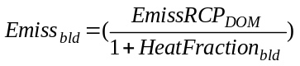
where 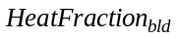 stands for the energy input to heat for the buildings sector divided by the sum of the energy input to heat and the direct fossil/bio energy consumption by the sector.

For the industrial sector, much of the nonCO2 emissions are from industrial processes, not energy. Therefore, the following formula is used:
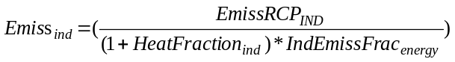
where 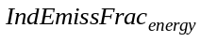 stands for the percentage of total industrial emissions (for a given gas) that are combustion-related (as opposed to process-related). Therefore for gases such as N2O that come primarily from process emissions, moving heat-related emissions from ENE to IND doesn’t really change much.

High-GWP gases
Because no dataset (either from the RCP process or from EDGAR) is available, the EMF-21 study is used here. Emissions are read in for 1990, 2005, and 2020, along with MAC curves from the EMF study. Some disaggregation was required; the mapping followed the scheme below:
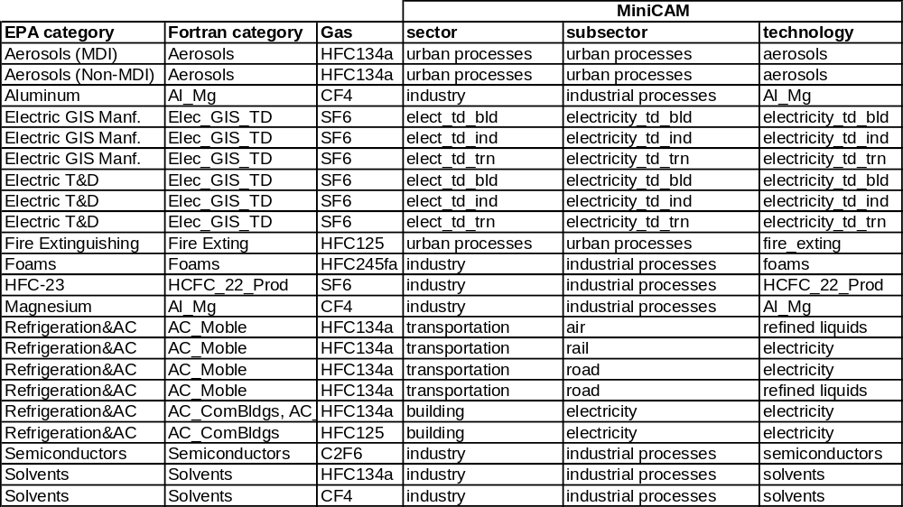

In summary, the EPA categories were first mapped to Fortran MiniCAM categories; the calculations for disaggregating Refrigeration&AC were done back in 2001, and have been preserved as no direct links to the source data/assumptions have been preserved. The Fortran MiniCAM calculations disaggregated Refrigeration&AC emissions between mobile and stationary sources, for instance.

The emissions from the Fortran categories were then assigned to corresponding GCAM technologies, and disaggregated according to output shares. The high-GWP gases are all assumed to be driven by outout, not input; that is, if cars become more fuel-efficient in the future, it will reduce fuel consumption but not refrigerant emissions. Where a single Fortran category applies to multiple GCAM technologies, disaggregation takes place on the basis of output. “Output” of all urban processes is assumed to grow with population, and output of all industrial processes grows with output of the industry sector for each region. Note that most data processing for transportation-related emissions takes place in the transportation input module workbook (input/energy/transportation/Input Module).

BC and OC
Tami Bond provided data by RCP category. This data was used to scale the Bond and Streets (2003) data, as the latter mapped well to the GCAM categories. The only disaggregation required in using this latter dataset was separating commercial from traditional biomass emissions in the regions where the designation applies.

GDP Control Functions
The functional form of the GDP control functions in GCAM is complicated and this will only briefly go over it. In summary, there are seven relevant input parameters: one from the data (input-emissions), and six co-dependent user-set parameters. The parameters basically determine how much emissions each region is controlling for each technology in the base years, and how much it will control going forward. Because the GDP control function would be redundant with a MAC curve (they are separate functions that get multiplied), only one is used for each technology/gas. MAC curves tend to be used for GHG’s (CH4, N2O, and high-GWP’s) and GDP-control functions are used for pollutant gases, but really the distinction is drawn by data availability. Where the EPA published a MAC curve for EMF-21, we use the MAC curve and no GDP control function. Where we don’t have that data, we use a GDP control function. In reality, even the GHG non-pollutant gases might be controlled by practices designed to limit pollutants, as strategies to reduce NOx will reduce N2O, for example.

In any case, the GDP control function assumes logistic controls approaching a defined “max-control” as GDP increases. The parameters are as follows:

tag name | Function
input-emissions | the amount of emissions in the base year
max-control | the maximum percentage of emissions that can be controlled
gdp-mid-control | the per-capita GDP (ppp) at which half of the possible controls are in place
gdp-control-range | the range of GDP between 10% and 90% of max-control
tech-diffusion | the rate at which gdp-mid-control decreases over time
uncontrolled-emiss-coef | the emissions coefficient (emissions / driver) if no controls were in place
final-emiss-coef | the emissions coefficient at max-control

The values of these parameters are generally set so that (a) the uncontrolled-emiss-coef is similar for the same technology across regions, (b) the 1990 predicted model emissions match actual emissions from inventories, where applicable, (c) the gdp-control-range is the same fraction of the gdp-mid-control for a given technology across regions, and (d) the final-emiss-coef’s for a given technology generally converge across regions. These are the goals that we aim for—not necessarily what’s there!

The figure below demonstrates the principle of emissions controls; the three curves all have the same gdp-mid-control, but differ in the gdp-control-range and the max-control. Note that the figure does not take tech-diffusion into account; for criteria pollutants, this would have the effect of making all of the curves steeper assuming GDP increases over time (i.e. more controls at lower GDP levels).

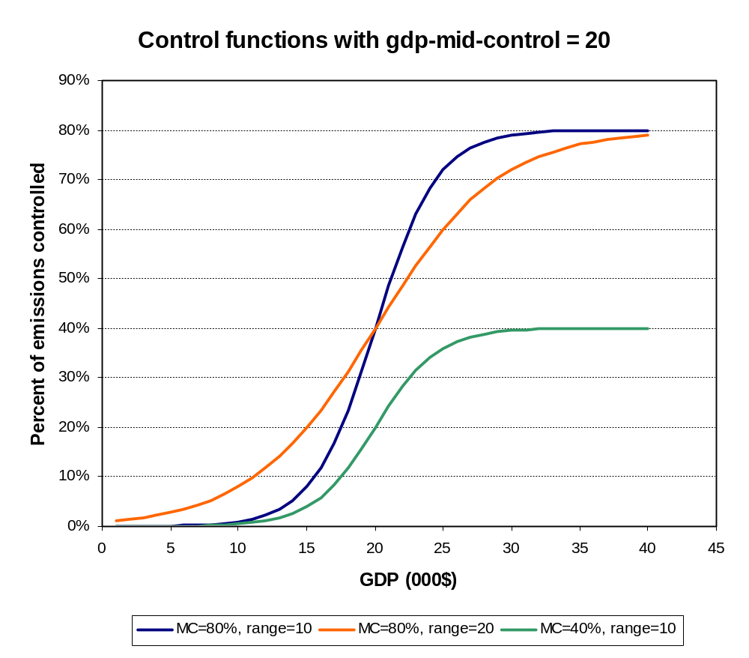

Tech-diffusion is constant for criteria pollutants across regions and technologies; the effect is that gdp-mid-control is assumed to decrease at 0.5% per year, corresponding to emissions reduction technologies becoming less expensive over time. Uncontrolled-emiss-coef’s for new technologies (e.g. hydrogen production, integrated gasification combined cycle (IGCC)) are based, where possible, on literature estimates, but for many of these we are using place-holder (though low) values at present. This may be adequate as a long-term solution—in addition to not being known, it is generally thought that emerging energy technologies such as IGCC, coal-to-liquids and coal-chemical hydrogen production will not generate much in the way of non-CO2 emissions, because the pollutants have to be scrubbed before the chemical processes can take place. In any case, the bottom line is that every technology that might ever come in and produce emissions is assigned an emissions coefficient. These are based on the literature where possible. Future emissions from all technologies are controlled by either a GDP-based control function, or by a MAC curve; the latter only applies in the case of a carbon price.

[Added March 2010] One final point is that for industrial energy use, at this point in the processing, we have estimates for emissions and coefficients for all industrial energy use by each fuel. These need to be disaggregated into the following industrial demands on each fuel:
Industrial energy use / fuel / conventional technology
Industrial energy use / fuel / cogen technology
Process heat cement / fuel / technology

To do this disaggregation, we assume equal coefficients of non-CO2 gas emissions amongst all three of these sources. That is, the original coefficients were calculated using total industrial energy use (all three of these categories together).

Agriculture and Land-Use System
Input Data\Aggregated AgLU GHG Data.xls
Aglu Input Module\NonCO2_AgLU_input.xls
Non-CO2 gases in AgLU are split into three categories, each of which gets its own xml input file to GCAM: the agriculture sector (crops only), livestock, and unmanaged land (emissions from open fires not on agricultural lands). The emissions sources and disaggregation techniques vary somewhat between the three categories; this is addressed in detail below. For the most part, they follow the same method as the energy system emissions, but the following changes should be noted:
- With the exception of unmanaged emissions, all ag emissions are tracked at the sector level, not the technology level. With 14 regions, 12 crops, 18 AEZ’s, 9 periods, and ~8 gases, there would have been way too much stuff to track these emissions at the technology level. This change required a modification to the nonCO2 code.
- GDP control functions are only used for agricultural waste burning; all other emissions are assumed to be unresponsive to GDP. In previous versions MACs were assumed for only livestock abatement; the source of the MAC curves was not known however, and the EPA study for EMF 21 provided MAC curves for N2O and CH4 abatement from all agriculture. These latter MAC curves are now used, for all agricultural sectors (livestock and crop production).
- All emissions from agricultural waste burning are given the “_AWB” suffix, whereas all emissions from both the livestock and agricultural sectors that are not from ag waste burning are given the “_AGR” suffix. This is necessary because otherwise two RCP emissions categories would get merged in a single GCAM technology. It doesn’t matter for anything in the model but users ought to be aware of it. No other gases are tagged by their RCP emission category.
- Drivers are calculated from interpolated 1990-2005 data, rather than actual 2000 agricultural data. The model time periods reflect rolling five-year averages in any case, and any large, non-linear changes in ag production or land cover would probably be driven more by statistical abnormalities than actual boom/bust behavior.

Agricultural and Livestock Sectors
The agricultural and livestock sector data is from the following sources:
CH4 | EDGAR 2000, scaled to RCP
N2O | EDGAR 2000, scaled to RCP
NOx | EDGAR 2000, scaled to RCP
CO | EDGAR 2000, scaled to RCP
NMVOC | EDGAR 2000, scaled to RCP
NH3 | Lex Bouwman and RCP
BC | Tami Bond for RCP
OC | Tami Bond for RCP

As in the energy system, the first step to using the EDGAR data was to disaggregate China and Korea; this is done depending on the category. In general, China accounted for more than 95% of the emissions for all categories:

 | China | Korea | Source
fertilizer use | 98% | 2% | Bouwman NH3 dataset
rice cultivation | 97% | 3% | Rice production (FAO)
enteric fermentation | 97% | 3% | Feed to livestock (FAO)
manure management | 97% | 3% | Feed to livestock (FAO)
agricultural waste burning | 98% | 2% | waste biomass production (calculated from FAO)
crop production | 98% | 2% | FAO
unmanaged manure | 98% | 2% | feed inputs to pastoral production, FAO

The next step was to assign the EDGAR categories to intermediate categories, that are then assigned to GCAM technologies on the basis of output shares. This is shown in the table below (pasted directly from the Aggregated Aglu GHG Data.xls workbook):

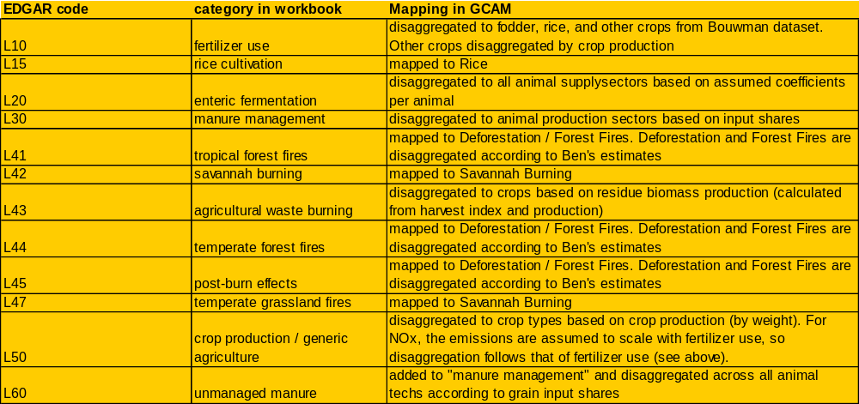
Note: The categories L41 to L47 are currently based on a database provided for the RCP project, so the mapping indicated in this table should be ignored.

In summary, crop output was used as the driver for emissions from crops (the alternative would have been land used). However, for disaggregating the base year emissions from the emissions categories to GCAM technologies, more nuanced approaches were generally used. For agricultural waste burning, the amount of residue biomass produced by each crop, in kt, was calculated from the crop output in kt (from FAO) divided by the harvest index of each crop (calculated by Jay Gregg). As well, for “crop production / generic agriculture,” the crop output in kt was used as the basis for emission disaggregation, rather than Gcal, because one of the crops (FiberCrop) is not represented in terms of Gcal.

Feed input was used as the driver for emissions from animals; it is assumed that ruminant emissions scale with the amount of feed consumed rather than the number of calories of beef/dairy produced. For CH4, a bottom-up calculation was used to assign the emissions to the different animal supplysectors in each region, because of the very different emissions profiles of the different animals. The disaggregation was based on the following table of CH4 emissions in kg per animal per year (source: IPCC,
http://www.ipcc-nggip.iges.or.jp/public/gp/bgp/4_1_CH4_Enteric_Fermentation.pdf ):

GCAM region | IPCC region | Dairy | Beef | Pork | Poultry | Sheep/Goat
USA | North America | 118 | 47 | 1.5 | 0 | 6.5
Canada | North America | 118 | 47 | 1.5 | 0 | 6.5
Western Europe | Western Europe | 100 | 48 | 1.5 | 0 | 6.5
Japan | Asia | 56 | 44 | 1 | 0 | 5
Australia_NZ | Oceania | 68 | 53 | 1.5 | 0 | 6.5
Former Soviet Union | Asia | 56 | 44 | 1 | 0 | 5
China | Asia | 56 | 44 | 1 | 0 | 5
Middle East | Africa and Middle East | 36 | 32 | 1 | 0 | 5
Africa | Africa and Middle East | 36 | 32 | 1 | 0 | 5
Latin America | Latin America | 57 | 49 | 1 | 0 | 5
Southeast Asia | Asia | 56 | 44 | 1 | 0 | 5
Eastern Europe | Eastern Europe | 81 | 56 | 1.5 | 0 | 6.5
Korea | Asia | 56 | 44 | 1 | 0 | 5
India | India | 46 | 25 | 1 | 0 | 5

These numbers were multiplied by animal stocks in each region to generate an estimate of the methane emissions share from each animal type. These bottom-up estimates were only used to scale the EDGAR emissions between the five animal types in each region; the emissions totals in the model are from EDGAR. The emissions were then disaggregated to technology (feed type) based on the mass of the feed (FAO data). Manure management emissions were assigned to all animal technologies purely on the basis of the mass of the feed input. The two sources of emissions (manure and enteric) were aggregated, as there is no reason to keep them separate for this project.

For N2O and NH3, data on “unmanaged manure” was available. These “unmanaged” emissions were added to the “managed” (or confined) manure emissions and disaggregated to all animal technologies (in both the pastoral and mixed subsectors) according to grain input shares.

Categories L41 through L47 are in the unmanaged land sector, and will be addressed later in this document. At present, EDGAR is not used as the source for these emissions.

The Bouwman NH3 dataset disaggregated emissions to a number of categories, shown in the table below (pasted directly from the Aggregated AgLU Input Data workbook):

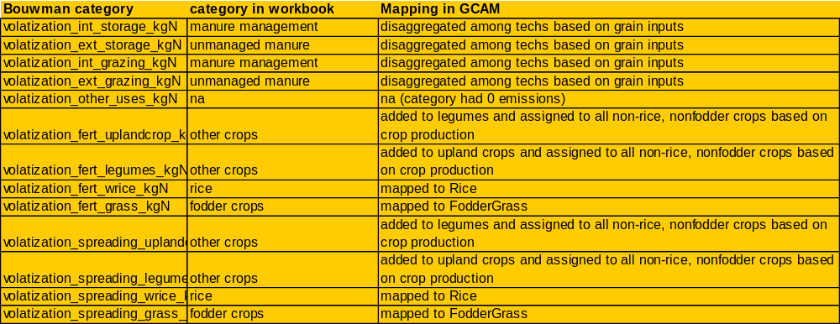

In summary, FodderGrass and Rice emissions from fertilizer and manure spreading were aggregated and assigned to these two sectors. The upland crop and legume emissions were aggregated, and divided among the seven GCAM crops not otherwise specified in this dataset (Corn, Wheat, OilCrop, MiscCrop, SugarCrop, FiberCrop, and OtherGrain). All emissions associated with fertilizer use were assigned to crops in the same proportion. In other words, N2O from fertilizer use and NOx from generic (non-burning) agriculture were both assumed to follow the same crop disaggregations as NH3 in the Bouwman dataset.

GDP controls
As indicated above, a GDP-based emissions control function is used for all agricultural waste burning. In general, the parameters are chosen so that regions with high levels of ag waste burning per unit of crop output converge towards the totals in the developed world at some point in the future. The same exact parameters were applied to each gas, as the control “technology” is simply to stop burning. Unlike a power plant, where one might control SO2 but not CH4, for example, in the agricultural sector, reducing the amount of burning will simultaneously reduce all gas emissions. However, the control parameters chosen at present are quite modest, as even in the developed world there is a fair amount of agricultural waste burning. Note also that the EPA’s MAC curves for abatement of agricultural CH4 and N2O are not applied to the agricultural waste burning emissions of these substances.

Unmanaged Land Technologies
There are three unmanaged land “technologies”: savannah burning, deforestation, and forest fires. Savannah burning and forest fires are driven by unmanaged land, and deforestation is driven by land-use change. It is assumed that savannah burning doesn’t represent land conversion (from unmanaged to farmland), but rather burning that is the nature of the biome. The rules of unmanaged land technologies are as follows: the input to the unmanaged land technologies is unmanaged land, and the output of the unmanaged land technologies is land use change, the decrease in land cover of the specific category. So savannah burning and forest fires are driven by input, and deforestation is driven by output. Where a region/AEZ has net afforestation in any time period, the driver for deforestation in this period is 0, and all emissions will likewise be 0.

The data was provided by the RCP process. Forest fires and deforestation were disaggregated in each region according to estimates put together by Ben Bond-Lamberty; the November 2010 update adjusts these estimates. Because actual (real-world) deforestation emissions are driven by gross deforestation over a one-year period rather than average net deforestation over a 15-year time period, positive emissions may have been observed in 2000 in regions/AEZ’s that nevertheless had net afforestation from 1990 to 2005. Moreover, the emissions coefficients (kg gas / m2 of land changed per year) may show a great deal of variability, reflecting that our model proxy of the driver can be quite far from the actual driver.

GCAM region | Deforestation share
Former Soviet Union | 5%
Canada | 1%
USA | 5%
China | 20%
Australia_NZ | 5%
Southeast Asia | 90%
India | 50%
Latin America | 80%
Middle East | 90%
Western Europe | 90%
Eastern Europe | 90%
Japan | 95%
Korea | 95%
Africa | 50%

For this reason, several of the fractions from Ben’s original estimates were adjusted, such that all regions get reasonably similar coefficients of deforestation-related emissions. The effect of this adjustment was generally to move some of the emissions from “deforestation” into “forest fires”; no adjustments changed the overall net emissions from unmanaged forests.

For the most part, the present approach works better than the previous one, which had the problem that a number of regions that had net afforestation across the whole region from 1990 to 2005 could either not match the base-year inventory, or could not have any future emissions. Now that each region is disaggregated into a number of AEZ’s, almost all regions (all but the USA) have net deforestation in some AEZ, so these AEZ’s can produce the observed base-year emissions, and all AEZ’s can be given the same coefficient such that future emissions are not confined only to those with net deforestation in the base years. This corrects one of the primary issues with the non-CO2 representation noted in prior editions of this document.

There are still a number of ways in which the model code for non-CO2 emissions could be improved. First, one ought to be able to switch from input-emissions to emissions coefficients, going from base years to future years. There will always be wide heterogeneity in calculated base year emissions coefficients throughout the energy, agriculture, and land systems, as the real-world drivers for these emissions (and the reporting methods) are complicated. However, going forward, a model user ought to be able to assign similar emissions coefficients to similar technologies. Right now this is not possible without hard-wiring coefficients in all periods, including base years.

Second, there ought to be consistency in functional form and in implementation between GHG price-induced abatement and GDP-induced abatement (i.e., for health and local environmental protection). At present a given emissions source could be assigned two abatement functions, even though both functions would presumably represent the same emissions control technologies.

In terms of improving the functional form, it would be ideal if this were somewhere between the current MAC function (piece-wise linear with 5-15 points) and the current GDP control function (S-curve with five parameters, four of which are user-defined; the fifth is calculated by the model from the other four). We should probably aim for 2-3 parameters per emissions source/gas, as well as a parameter specifying whether each abatement curve is applied to either the C price or the GDP.

Finally, for technologies using an input driver, it should be specified which input is used. At present all inputs are added together (even if their units differ). In the future we’ll probably want to track fertilizer inputs to ag production technologies, and to model the N2O emissions as a function of these inputs, without also adding the water demands and any other inputs (e.g. capital, labor) being explicitly modeled.

